
NAME: BISMA FATIMA
CLASS: CS A
ROLL NO: F24605036
COURSE: INFORMATION SECURITY
COURSE CODE: CS-291
LECTURER: MISS ATTIA ASHRAF

LAB TASK 02

Lab Activities
1. File System Comparison: Write a brief comparison (200 words) between the file system structures of Windows and Ubuntu.
ANS:
Windows primarily uses the NTFS (New Technology File System), while Ubuntu (a Linux distribution) typically uses EXT4 (Fourth Extended File System). These systems differ significantly in architecture, hierarchy, and features.
- Hierarchy:
  - Windows organizes files using drive letters (e.g., C:\, D:\), with each partition treated as a separate root.
  - Ubuntu follows a single-root hierarchy starting from /, with all directories and mounted devices branching from this root.
- File Naming & Permissions:
  - Windows is case-insensitive (e.g., File.txt = file.txt), while Ubuntu is case-sensitive.
  - Ubuntu uses Unix-style permissions (read, write, execute for owner, group, others), whereas Windows uses Access Control Lists (ACLs) for granular permission control.
- System Features:
  - NTFS supports compression, encryption (BitLocker), and journaling.
  - EXT4 also supports journaling, along with symbolic links, mount points, and extended attributes.
- Path Lengths:
  - Ubuntu allows paths up to 4096 characters, while Windows is limited to 260 characters by default.

2. VM Benefits: Summarize (150 words) why a VM is ideal for information security experiments, especially for tasks like malware testing.
ANS:
A virtual machine (VM) is an essential tool for conducting information security experiments, particularly malware testing, due to its ability to provide a safe, isolated environment. VMs operate independently from the host system, minimizing the risk of infecting or damaging the actual hardware. This isolation allows researchers to analyze malicious software without compromising their primary operating system. VMs also support snapshots, enabling users to save the system state and revert to it after testing, which is invaluable for repeated experiments. They offer flexibility to simulate various operating systems and network configurations, making it easier to observe malware behavior across different environments. Additionally, VMs are cost-effective, allowing multiple setups on a single machine without the need for extra hardware. Their controlled, customizable nature makes them ideal for learning, testing security tools, and developing defensive strategies in a secure and repeatable manner. Overall, VMs are a cornerstone of modern cybersecurity research and education.

3. Command Practice: Run the commands listed in Step 3 and document the output for each command.
Step 3: Basic Ubuntu Commands
1. Navigating the File System:
o Display current directory:
COMMAND:
pwd
OUTPUT:
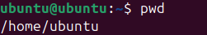
o Change directory:
COMMAND:
Cd path/to/directory
OUTPUT:
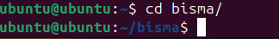

o List directory contents:
COMMAND:
ls
OUTPUT:

o List detail directory contents:
COMMAND:
ls -l
OUTPUT:
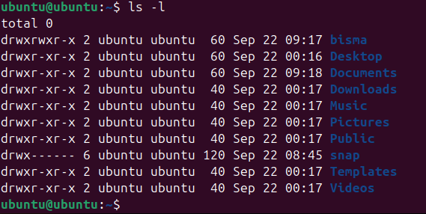

2. Managing Files and Directories:
o Create a new directory:
COMMAND:
mkdir new_directory
OUTPUT:
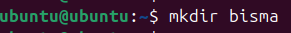
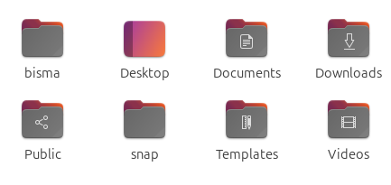
o Create a new file:
COMMAND:
Touch newfile.txt
OUTPUT:
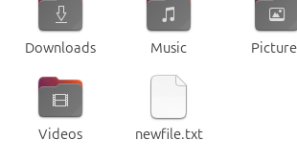
o Copy a file:
COMMAND:
cp filename.txt path/to/directory
OUTPUT:
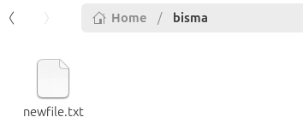
o Move a file:
COMMAND:
mv filename.txt /path/to/directory
OUTPUT:

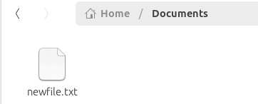
o Delete a file:
COMMAND:
rn filename.txt
OUTPUT:

4. Installing and Removing Software:
o Update package lists:
COMMAND:
Sudo apt update
OUTPUT:
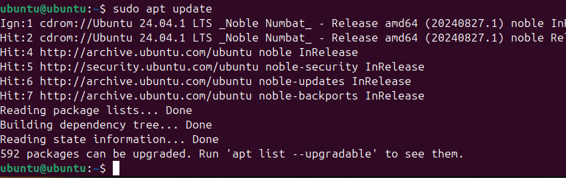

o Install a package:
COMMAND:
Sudo apt install package_name
OUTPUT:
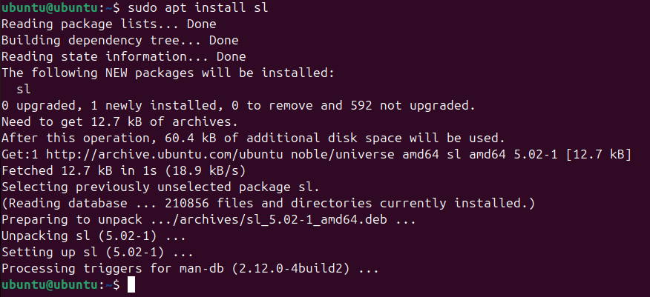
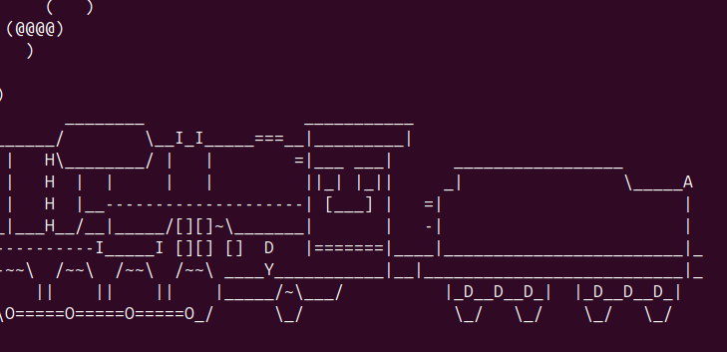

o Remove a package:
COMMAND:
Sudo apt remove package_name
OUTPUT:
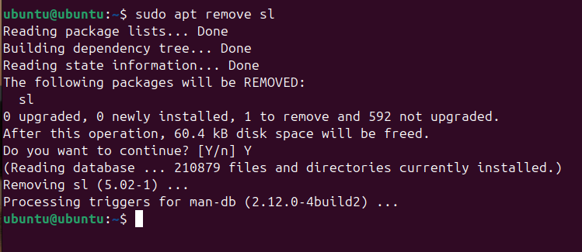

5. Navigating the File System
o Change the current working directory to the specified path.
COMMAND:
cd /path/to/directory
OUTPUT:
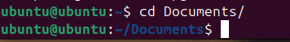

o To go back to the previous directory:
COMMAND:
cd ..
OUTPUT:
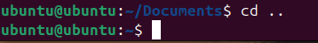
o To go to Home directory:
COMMAND:
cd ..
OUTPUT:
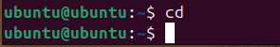
6. Viewing Command History
o Clear Terminal screen
COMMAND:
clear
OUTPUT:
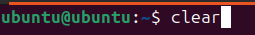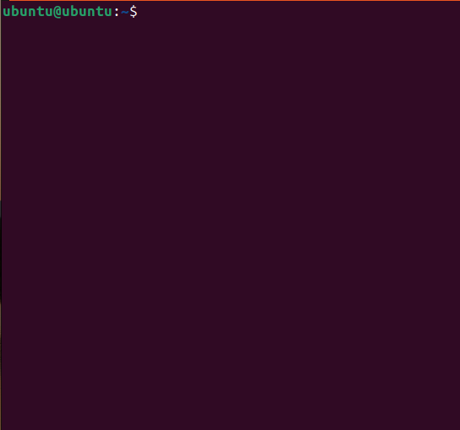

o Display a list of previously executed commands with line numbers, making it easier to recall and reuse past commands.
COMMAND:
history
OUTPUT:
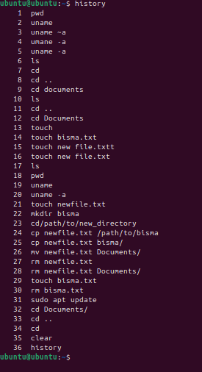
o Ubuntu comes with built-in security tools like ufw (Uncomplicated Firewall). View the status of the firewall using:
COMMAND:
Sudo ufw status
OUTPUT:
